Year 1 websites and links to enable children to learn at home.

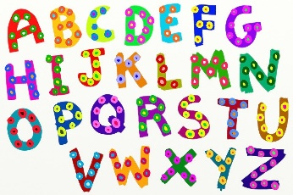
Literacy
https://www.phonicsplay.co.uk/ - free phonics activities
https://www.teachyourmonstertoread.com/ - free on desktop (cost to download on ipads)
https://kids.classroomsecrets.co.uk/category/year-1/year-1-phonics/ - phase 4 and phase 5 phonic activities
https://www.topmarks.co.uk/Interactive.aspx?cat=43 – a variety of ipad/computer friendly activities for maths and literacy
https://uk.ixl.com/ela/year-1 - literacy and maths activities (there is a subscription cost to this)
https://www.abcya.com/grades/1 - maths and literacy games (can be used on on ipads or computers)

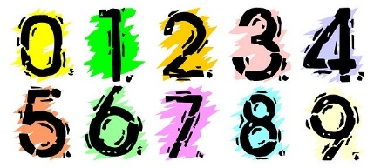
Maths
https://www.twinkl.co.uk/resources/2014-curriculum-maths-resources/ks1-maths-resources/ks1-maths-resources-year-1 - a wide variety of printable resources for maths, literacy and phonics (4 weeks free for closed schools)
https://www.oxfordowl.co.uk/for-home/kids-activities/fun-maths-games-and-activities/#maths-5-7 - year 1 resources and activities.
http://www.mathsphere.co.uk/resources/MathSphereSampleWorksheets.htm - printable maths worksheets, free resources, fun and games.
https://coolsciencelab.com/math_magician_addition.html - mental maths addition and subtraction (beat the clock)

