WHARTON PRIMARY SCHOOL

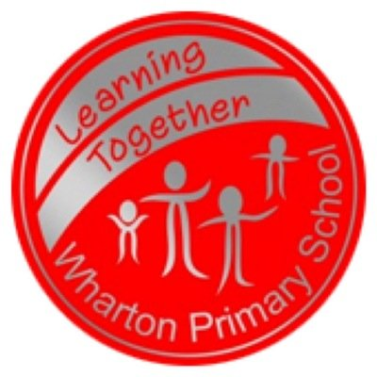

Helping your child at home

with Maths activities

In EYFS & KS1 the children have a daily Maths lessons each morning. Maths lessons follow the objectives in the EYFS Curriculum and National Curriculum and cover the following areas:

- Using and applying maths skills
- Counting and understanding number
- Knowing and using number facts
- Calculating
- Understanding shape
- Measuring
- Handling Data

We have put this booklet together to focus on the 4 calculations of addition, subtraction, multiplication and division and how these are taught across EYFS, Year 1 and Year 2.

PROGRESSION THROUGH CALCULATIONS FOR ADDITION

Early Years Foundation Stage

Children are encouraged to develop a mental picture of the number system in their heads to use for calculation. They develop ways of recording calculations using pictures, etc.

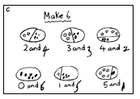

To begin with we encourage the children to use their fingers or counters to solve an addition calculation such as:

5 + 3 =

- We then teach the children to put a number in their head and count on to find the answer:

3 + 5 = Put 3 in their head and use their fingers to count on 5.

As the children become more confident with this we encourage them to put the biggest number first so they only have to count on the smallest amount. E.g. put 5 in their head and count on 3 more rather than putting 3 in their head and having to count on 5.

As well as using counters and mental strategies, the children are taught how to use a number track to solve addition calculations:

3 + 4 =

1
2
3
4
5
6
7
8
9
10

Put your counter on 3 and jump on 4 spaces.

As the children become confident with this strategy they will be encouraged to put the biggest number first.

Year 1

When children are confident with the strategies used in the Early Years Foundation Stage, the children move on to using number lines.

8 + 5 = 13
+1
+1
+1
+1
+1
0 1 2 3 4 5 6 7 8 9 10 11 12 13 14 15

Once children are confident in using a number line to count on in ones, we then show them how mental recall of number bonds can be used on a number line as a quicker strategy.

E.g. using knowledge of number bonds to 10:
+3
+ 2
8 + 5 = 13
0 1 2 3 4 5 6 7 8 9 10 11 12 13 14 15

Another way of recording this is:

8 + 5
8 + 2 + 3

10 + 3 = 13

They may also use near doubles to help to work out calculations and this would be recorded like this:

5 + 6
5 + 5 + 1
10 + 1 = 11

Re-ordering is a strategy used with calculations with more than 2 numbers. The children may re-order using number bonds:

E.g. 7 + 5 + 3
7 + 3 + 5

Or by using doubles:

E.g. 5 + 7 + 5
5 + 5 + 7

Y2

Children will begin to use number lines and then‘empty number lines’ themselves starting with the larger number and counting on.

- First counting on in tens and ones.

34 + 23 = 57

+10
+10

+1
+1
+1

34 44 54 55 56 57

- Then helping children to become more efficient by adding the units in one jump (by using the known fact 4 + 3 = 7).

34 + 23 = 57
+10
+10

+3

34 44 54 57

- Followed by adding the tens in one jump and the units in one jump.

34 + 23 = 57
+20
+3

34 54 57

- Using their knowledge of number bonds children become more efficient.

37 + 15 = 52
+10
+3
+2

37 47 50 52

Another way of recording this is:

37 + 15
7 + 5 = 12
30 + 10 = 40
40 + 12 = 52

Some calculations do not require a number line as mental strategies can be used.

E.g. using near doubles: 20 + 19
20 + 20 - 1

Column Addition
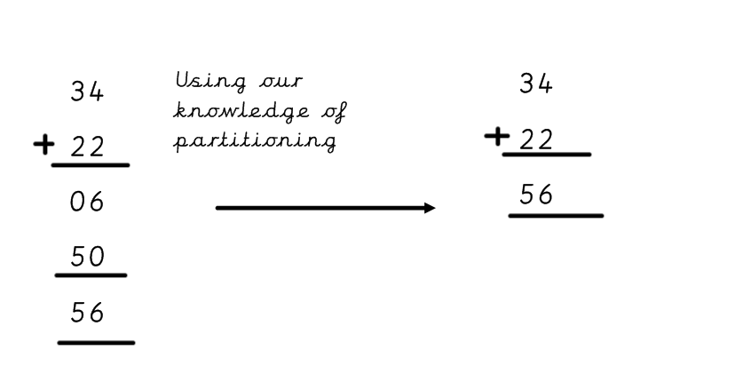

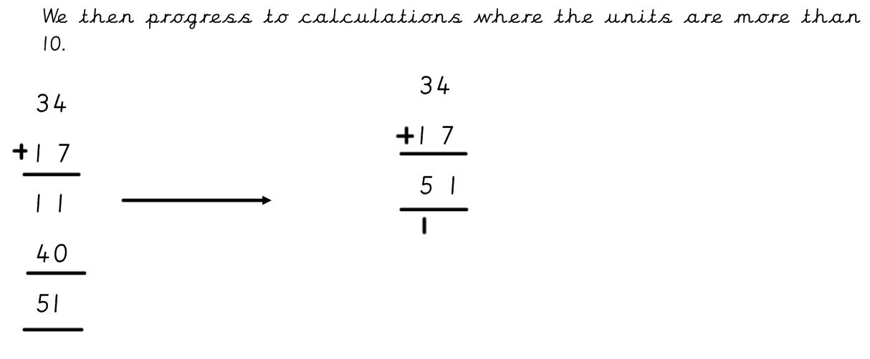

Please note, column addition will only be taught to children who are ready. We will let you know if your child has began to learn column addtion which will be later in the academic year. Please do not try to teach your child this method at home.

PROGRESSION THROUGH CALCULATIONS FOR SUBTRACTION

Early Years Foundation Stage

Children are encouraged to work practically to understand the concept of subtraction as taking away.

E.g. There are 5 biscuits on this plate. Take 3 of the biscuits to eat. How many are left on the plate?
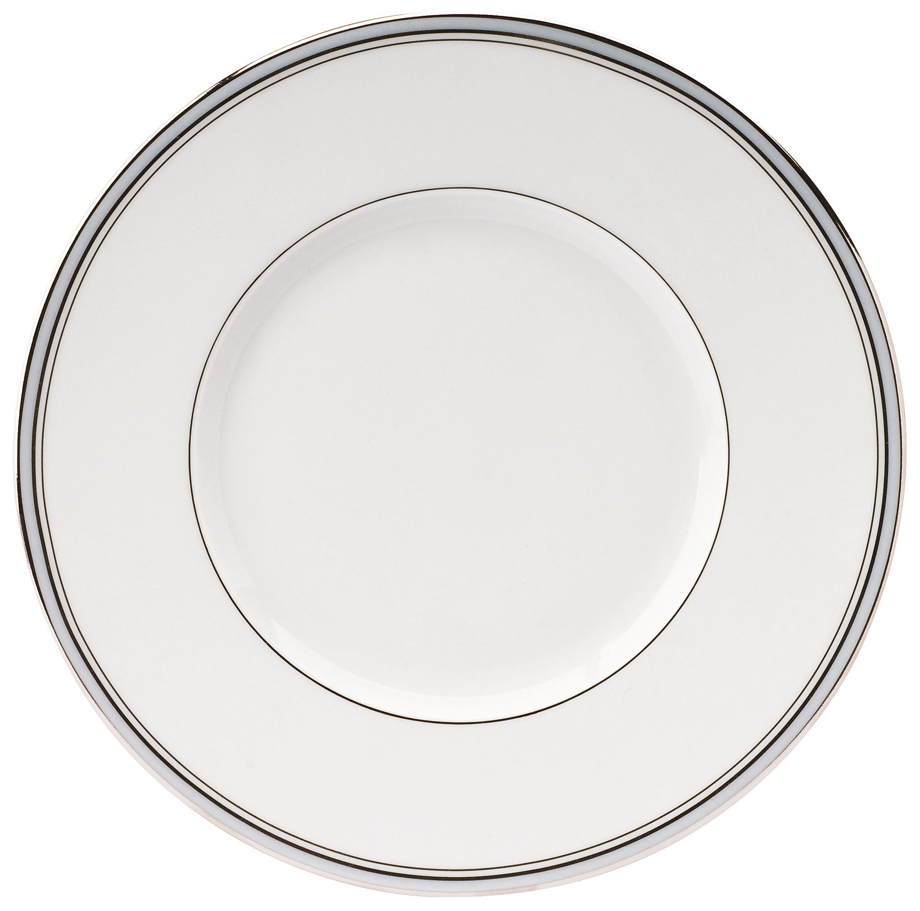


The children are taught to use their fingers or counters to work out simple subtraction sums.

As the children become more confident with using counters, they are taught to use a number track to work out subtraction calculations:

- - 4 =

1
2
3
4
5
6
7
8
9
10

Put your counter on 9 and jump back 4 spaces.

Year 1

The children use number lines and practical resources to support subtraction. Teachers demonstrate the use of the number lines to count back in ones as shown below:

6 – 3 = 3
-1
-1
-1

___________________________________
0 1 2 3 4 5 6 7 8 9 10

The number line should also be used to show that 6 - 3 means the ‘difference between
6 and 3’ or ‘the difference between 3 and 6’ and how many jumps they are apart.

0 1 2 3 4 5 6 7 8 9 10

Once children are confident in using a number line to count back in ones, we then show them how mental recall of number facts can be used on a number line as a quicker strategy.

E.g. using knowledge of number facts:
-3
- 4
13 – 7 =
0 1 2 3 4 5 6 7 8 9 10 11 12 13 14 15

Another way of recording this is:

13 - 7
13 – 3 – 4 so 13 – 3 = 10
10 - 4 = 6

Year 2

Children will continue to use number lines and begin to use empty number lines to support calculations.

Counting back

- First counting back in tens and ones.

47 – 23 = 24

- 10
- 10
-1
-1
-1

24 25 26 27 37 47

- Then helping children to become more efficient by subtracting the units in one jump (by using the known fact 7 – 3 = 4).

47 – 23 = 24
-10
-10
-3
24 27 37 47

- Subtracting the tens in one jump and the units in one jump.

47 – 23 = 24
-20
-3
24 27 47

- Using known number facts can help children become more efficient.

42 – 25 = 17
-20
-3
-2

17 20 22 42

Counting on

Some children find counting on to work out a subtraction sum more efficient if the numbers involved in the calculation are close together.

E.g. 82 – 79 =

+1
+1
+1
79 80 81 82

PROGRESSION THROUGH CALCULATIONS FOR MULTIPLICATION

Early Years Foundation Stage

Children will experience equal groups of objects and will count in 2s and 10s and begin to count in 5s. They will work on practical problem solving activities involving equal sets or groups, using pictorial imagery and recording.



Year 1

Children will continue to use pictorial recording to describe multiplication situations without being introduced to the multiplication sign or written calculation.

There are 3 sweets in one bag.
How many sweets are there in 5 bags?

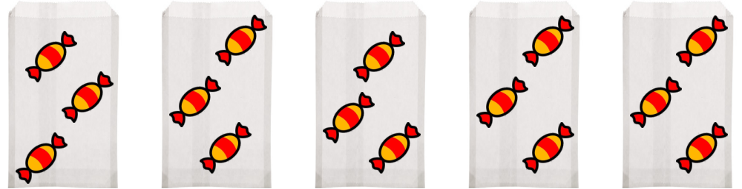

Year 2

Children will develop their understanding of multiplication and use jottings to support calculation:

Repeated addition

3 multiplied by 5 is 5 + 5 + 5 = 15

Repeated addition can be shown easily on a number line:
3 x 5 =

0 1 2 3 4 5 6 7 8 9 10 11 12 13 14 15

Write this addition fact as a multiplication fact.
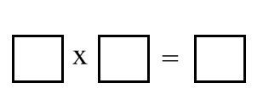
4 4 4 4 4 20

Commutativity

Children should know that 3 x 5 has the same answer as 5 x 3 but describes a different
situation. This can also be shown on the number line.

5
5
5

0 1 2 3 4 5 6 7 8 9 10 11 12 13 14 15

3
3
3
3
3

Arrays
Children should be able to model a multiplication calculation using an array. This knowledge will support with the development of the grid method and makes links to division.

5 x 3 = 15

3 x 5 = 15

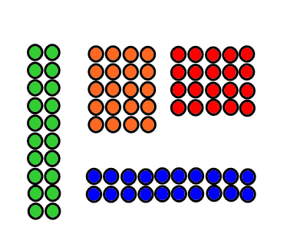
Here are 20 counters. How could you arrange them in equal rows? How could you use a number sentence to show your arrangement?

Extended Strategies

Children review multiplication as repeated addition and division as repeated subtraction by counting hops on a number line. For example, they find 4 multiplied by 6 by making 6 hops of 4.

Children understand the relationship between multiplication and division. For example, they state two multiplication sentences and two division sentences that relate to a particular array, for example:

5 x 2 = 10
10 ÷ 2 = 5

2 x 5 = 10 They use the image of an array to explain why, for example,
10 ÷ 5 = 2 2x5 gives the same answer as 5x2. They can also use the image to show how many fives make 10 and how many twos make 10.

PROGRESSION THROUGH CALCULATIONS FOR DIVISION

Early Years Foundation Stage

Children will understand equal groups and group items out in play and problem solving. They will count in 2s and 10s and later in 5s.

How many groups of 2 can you make from 6?

Year 1

Children will continue to use pictorial recording to describe multiplication and division without being introduced to the division sign or recorded calculation. At this stage division should be taught as grouping not sharing.


12 children want to play football, how many teams of 4 will there be?

Year 2

Children will develop their understanding of division and use jottings to support calculation.
E.g.
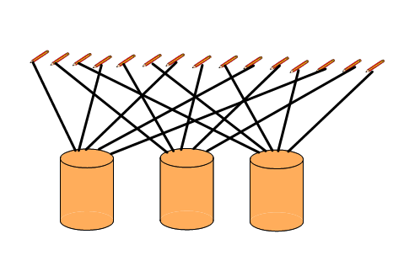
Sharing equally
Use sharing to answer division questions; Suppose 15 pencils were to be shared out between three children. How many pencils would each child get? Explain to me how you could work it out.

Grouping or repeated subtraction

Use practical equipment or objects to answer questions such as: How many 2’s make 12? Relate this to the division 12 ÷ 2.

Use objects or a number line to support record or explain this. For example, starting from
12, jump back in steps of 2, or starting with 12 counters, keep on taking away 2 counters.

Record this as repeated subtraction and as division:
12 - 2 - 2 - 2 - 2 - 2 - 2 0
12 ÷ 2 6
12 divided by 2 equals 6

Repeated subtraction using a number line:

Show me on a number line how you could do: 12 ÷ 3 = 4

0 1 2 3 4 5 6 7 8 9 10 11 12
or

Using symbols to stand for unknown numbers to complete equations using inverse
operations. E.g.

 ÷ 2 = 4 20 ÷  = 4  ÷  = 4

Extended Strategies

At this stage the emphasis needs to be on GROUPING not SHARING.

Repeated subtraction

Children review multiplication as repeated addition and division as repeated subtraction by counting hops on a number line. For example, they find how many fours make 24, either by counting on or back 6 hops of 4.
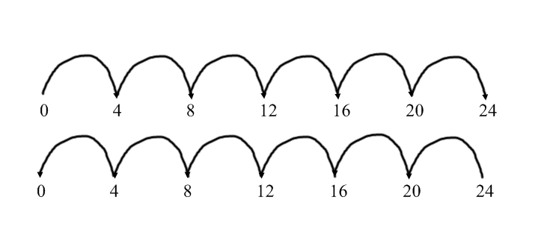

Children divide a number of objects by using grouping. They understand that one way to find 306 is to find how many sixes there are in 30.

Through practical experience, they understand that some division calculations have a remainder, for example 13 ÷ 4 3 remainder 1



