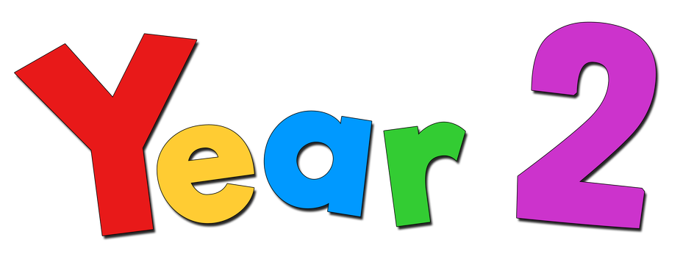
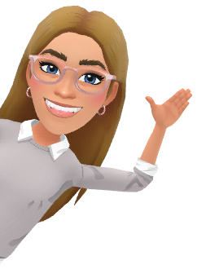

Welcome to

Your class teacher will be…
Miss Shakeshaft (KS1 S)
We will be supported by Mrs Bennett


Year 2 Routine
Your child should be in the school grounds by 8:25am each morning and an adult should be ready to collect them at 3pm. All children will enter school and leave school via the infant playground (through Miss Soudet’s classroom door). Notice of after-school clubs will be sent out half-termly.


Spellings and mathematics homework will be sent out each Friday and due in the following Friday morning. We encourage the children to access learning portals on Reading Eggs, Times TTRockstars and Purple Mash, to revise current or past topics during activities set each half-term. The children will be provided with a login strip, so they are able to login at home and in school. We will be using Seesaw to keep you updated on our year!


Every day in school, children will complete English, reading and maths lessons. Throughout the week, we will be engaging with geography/history, RE/PSHE, computing, PE, art/design & technology and music lessons. We will begin the year by exploring topics such as animals including humans, African safaris, mixing colours and everyday materials.

Snack & Milk
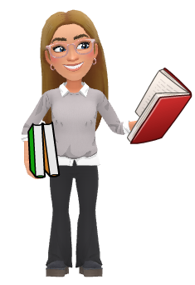
If you would like milk or toast, please pay for this on Parent Pay and you will be added to the half-termly lists. Please provide your child with a water bottle for during the school day.

Home Reading
In Year 2, we expect you to bring your reading book and record into school each day after reading for 10-15 minutes each night and being asked questions about what you have read. Your adults can then sign and add comments to celebrate your progress. We expect children to read at home at least three times a week. We have a reward system in school to celebrate those children that read regularly. Please look after school reading books, as there will be a charge of £5 for loss or intentional damage.

PE
Year 2 will have P.E. every Friday afternoon,
Please make sure your child has their labelled P.E. kit in school every day.
They will need:
Please also have a pair of trainers and jog pants/leggings as we will try to get outside as often as the weather allows us.

- White t-shirt
- Black shorts
- Black pumps

School closes for the summer holidays on Wednesday 23rd July and will re-open for the new term on Tuesday 2nd September. We look forward to working with you all and meeting everyone very soon. If you have any questions before then, please come and ask.
Have a lovely summer,

Miss Shakeshaft & Y2 team ☺

