
Welcome to Year 3!
Welcome to the first year of the Juniors. How exciting! In Year 3 we expect the children to respect each other and to have a positive attitude towards their learning and most importantly, have fun!
Class Teachers: Miss Shakeshaft (3S) / Mrs Mainprize (3M)

Teaching Support: Mrs Smyth, Mrs Jodie, Mrs Lucy & Miss Danielle.
P.E. Day: Tuesday
Please make sure your child has their P.E. kit in school every day.
They will need:
- White t-shirt
- Black shorts
- Black pumps
- Long sleeved jumper/top & tracksuit bottoms (outdoor kit)
.

All kit should be clearly labelled with your child’s name.
School is not responsible for the loss or damage of any personal possessions.

Snack:
Milk and toast are available to be ordered and paid for each half-term. Toast is £1.25 for the week. Please ensure your child brings a fresh bottle of water each day.

Homework:
- Spellings will be given each week to be tested the following week.
- Weekly mathematics homework will be set on a Friday.
- TTRockstars, Bedrock and Purple Mash are all online programmes/applications that we encourage our children to use at home. Weekly tasks will be set for the children to complete at their own leisure. Login strips will be given out at the beginning of the year.
In Year 3 we expect:
- Reading pouches, books and records to be brought back into school each day to be checked for home reading.
- Children to read a minimum of three times a week at home (3-4 pages = 1 reading session). If the right text is found, this should not feel like hard work at all!
- Children to be in school on time at 8:25 am and collected at 3:30pm.
- Weekly spellings and mathematics homework to be completed and handed in every Friday morning.

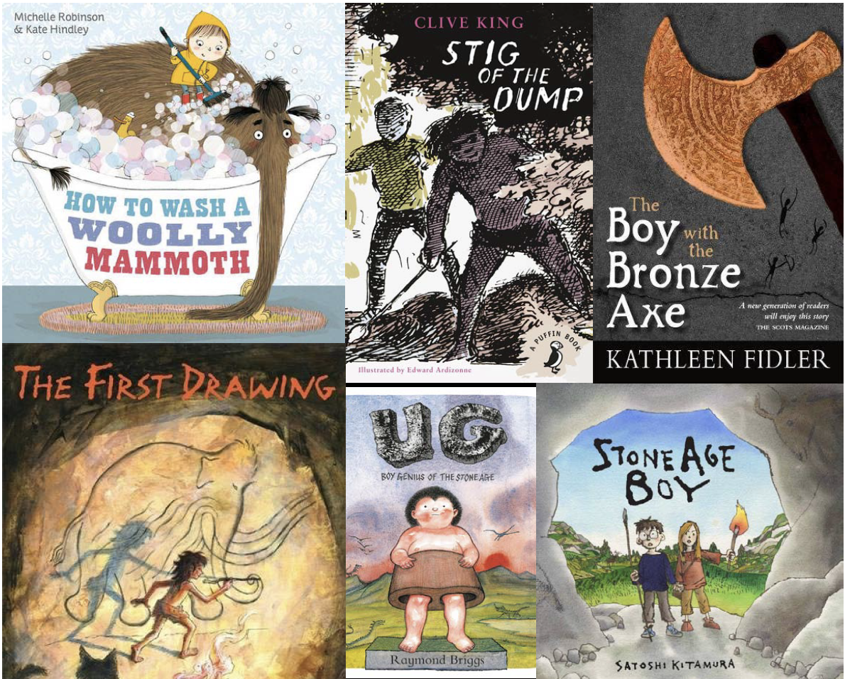
The main topic in the autumn half term:
‘Stone Age to Bronze Age’
This topic will look at these two historical periods. This topic will be a history topic, but will have links to our English, geography, computing studies and the arts.
We hope you have a fantastic, safe summer holiday and we will see you in September.
The children return to school on Tuesday 5th September and finish for half term on Friday 20th October
- Information about after-school clubs will follow in the new term *
If you have any questions before then, please contact the school office to arrange to speak to your child’s new teacher.
Miss Shakeshaft, Mrs Mainprize
& the Y3 Team 😊


