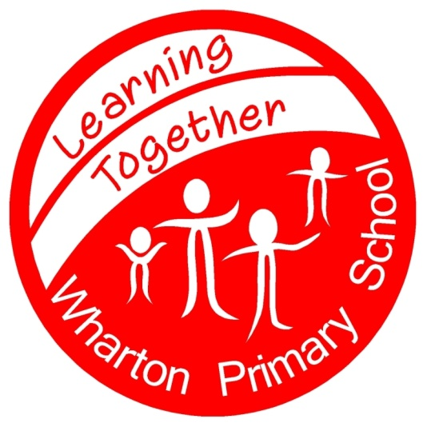 Wharton Primary School
Work Hard Persevere Succeed

16th January 2018

Dear Parents & Carers,
The Local Authority are gathering information this week that will determine our funding for the next year. One of the key factors is eligibility for Free School Meals.
You are eligible to claim Free School Meals if you receive;
- Income support
- Job seeker’s allowance (income based)
- Employment & Support Allowance (income related)
- The guarantee element of State Pension Credit
- Child Tax Credit but are not entitled to Working Tax Credit and the annual household income as assessed by HMRC does not exceed £16,190
- If you are an Asylum Seeker
If your child is in Reception, Year 1 or 2 and has a free lunch, it is still really important that you register your eligibility – you will then be entitled to free milk and school will receive additional funding to support your child’s learning.
We are offering entry into a cash prize draw (£25/£15/£10) for any parent registered for FSM by 3pm on 17th January – I am assured it’s really quick & easy to do.
You can register at www.salford.gov.uk/freeschoolmeals or by telephone on 0161 793 2500 option 3- we will receive notification once you have registered.
If you don’t have access to a computer, you can bring evidence of your allowance to the school office & staff will process the registration – again by 3pm tomorrow (17th).
Please ask at the office if you need any advice.

With Thanks for your Support,

Mrs Watson

