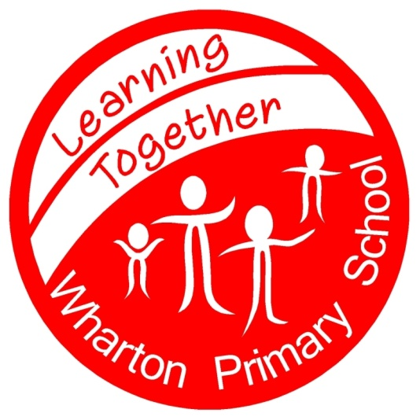 Wharton Primary School
Work Hard Persevere Succeed

4th September 2018

Dear Parents,
Welcome back to the new school year!
The children have made a great start today and settled in quickly to their new classes. There will be an opportunity for you to come into school to meet the teachers in the next couple of weeks (details will come to you soon) but should you have any questions or concerns, please speak to them at the start or end of the day.
We have one new classroom up and running in the Juniors and building work will continue for the rest of this month to complete our expansion – your patience is appreciated.
An important message for parents of Junior children;
One of our pupils has a significant nut allergy.
Medical advice given suggests that airborne traces of nuts may provoke an allergic reaction.
For this reason I need to insist that no foods be brought into school – either for snack or in lunch boxes, that may contain nuts. This includes cereal bars and sandwich spreads containing nuts. Lunchtime staff will be vigilant and may remove any foods that may present a risk – foods will be returned to parents unopened at the end of the day.
This decision is not negotiable - the safety of our children is as always the priority.
I appreciate your full co-operation in this matter.
We are trying to reduce the use of throw away plastic bottles in school and would encourage children to bring a reusable drinking bottle from home. The bottle will be named & sent home at the end of each week to be washed ready for the next week. Any reusable sports type bottle is ideal.

A great start to a new school year – I look forward to working with you to support your child’s learning.

Kind Regards,

Mrs Watson.

