

Wednesday 9th February

Wharton Phonics Newsletter

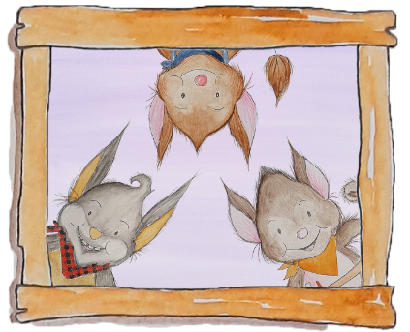

At Wharton, we are committed to developing a love of reading. Early reading skills and phonics knowledge play an essential role in this process. Secure phonics knowledge teaches children the necessary skills to be able to confidently read unknown and new words, allowing them to grow in confidence and enthusiasm with their reading.

As always, we are driven by maintaining the highest standards of education for all of our children. As a result, Mrs Hampson (EYFS & KS1) and Mrs Mainprize (KS2), our Phonics Leads in school, are excited to announce that we will be launching our new phonics scheme – ‘Supersonic Phonic Friends’ across EYFS, KS1 and Lower KS2 this term.

The children will soon be introduced to some new, friendly characters who represent each phonics skill involved in developing their early reading. Supported by their Supersonic Phonic Friends, our new approach will ensure children develop confidence and apply each skill to their own reading and writing.

We are very lucky and excited to have a phonics consultant, Anna Lucas, visiting this week and next to help us launch our new phonics scheme.

Watch this space to find out about future parent workshops!

Audit of home reading

In order to facilitate the transition to our new approach to reading, we will be removing all reading books in KS1 from Thursday 10th February. This will allow us to audit the books and ensure that, following the launch of our new scheme, the children will all have access to a high quality text, linked to the sounds that they will be learning in school.

All children will receive a new reading book following the audit when we return from the half term break.

Additional Games

<https://www.education.com/games/word-patterns/>

<https://ictgames.com/mobilePage/forestphonics/index.html>

<https://www.ictgames.com/mobilePage/spookysounds/index.html>

Suggested activities for holiday reading

<https://www.phonicsplay.co.uk/resources>  
Our children love to play Buried Treasure, Picnic on Pluto and Dragon’s Den games. You can encourage them to sound out and blend each word, before deciding if it is real or fake.   
The following range of free eBooks can be accessed at home once you have set up a free account:  
<https://home.oxfordowl.co.uk/reading/free-ebooks/>

Phonics Newsletters

To accompany our phonics teaching in class, there will also be regular newsletters to help the children at home. This will help you to work with your child at home on their key words for the week as well as providing an overview of the sounds that they have been working on, with examples of words and any accompanying spelling rules.